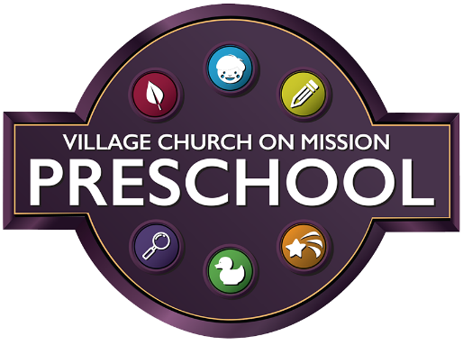
Preschool Monthly Tuition
2021-2022

One unit of Preschool is $80.00
One unit of Extended Preschool Day (EPD) is $90.00
The following are the enrollment opportunities and monthly tuition for each:
T-Th 3s (am) $160.00
AM 3s with 1 day EPD (T or Th) $250.00
AM 3s with 2 days EPD (T and Th) $340.00
MWF 4s (am) $240.00
AM 4s with 1 day EPD (W or F) $330.00
AM 4s with 2 days EPD (W and F) $420.00
PM 5s TWTHF (pm) $320.00
PM 5s with 1 day EPD (T or Th) $410.00
PM 5s with 2 days EPD (T and Th) $500.00

Registration/Activity Fees:
Registration Fee $150.00
Enrollment Deposit $ (One-month tuition total)
(This deposit will be applied to your account for Sept 2021 and will hold your spot for the upcoming year.)
Enrollment will be confirmed February 26, 2021 with instructions on paying Registration fee and Tuition deposit.
Make checks payable to: Village on Mission Preschool

